

Assessment 3:

Prototyping

Fernando García Sanz

Antonio de Padua Díaz Martínez

**Content:**

Youtube: 3

Nielsen’s Heuristics Analysis: 3

Van Duyne Patterns’ Analysis: 11

Twitch: 15

Nielsen’s heuristics: 15

Van Duyne’s design patterns: 19

Netflix: 25

Nielsen’s heuristics: 25

Van Duyne’s design patterns: 29

OUR WEB: 34

Main Goal: 34

Functionalities: 34

Scenario of use: 40

# Youtube:

Youtube is the main platform of videos in the current internet. It allows the user to play, share and upload videos of any topic, always respecting the legal standards, and leave his feedback in form of comments or likes/dislikes in the videos.

Youtube also allows the publisher to stream live videos, allowing the user consume content which is being published by the channel at the moment. Users also may subscribe to their favourite channels and be updated about their content.

## Nielsen’s Heuristics Analysis:

According to Jakob Nielsen, a website must follow ten patterns or laws to provide the consumer a good user experience. We are going to analyse Youtube according to these patterns:

1. Visibility of System Status

The system should always keep informed the users about its performance, the tasks it is working on, in a reasonable time.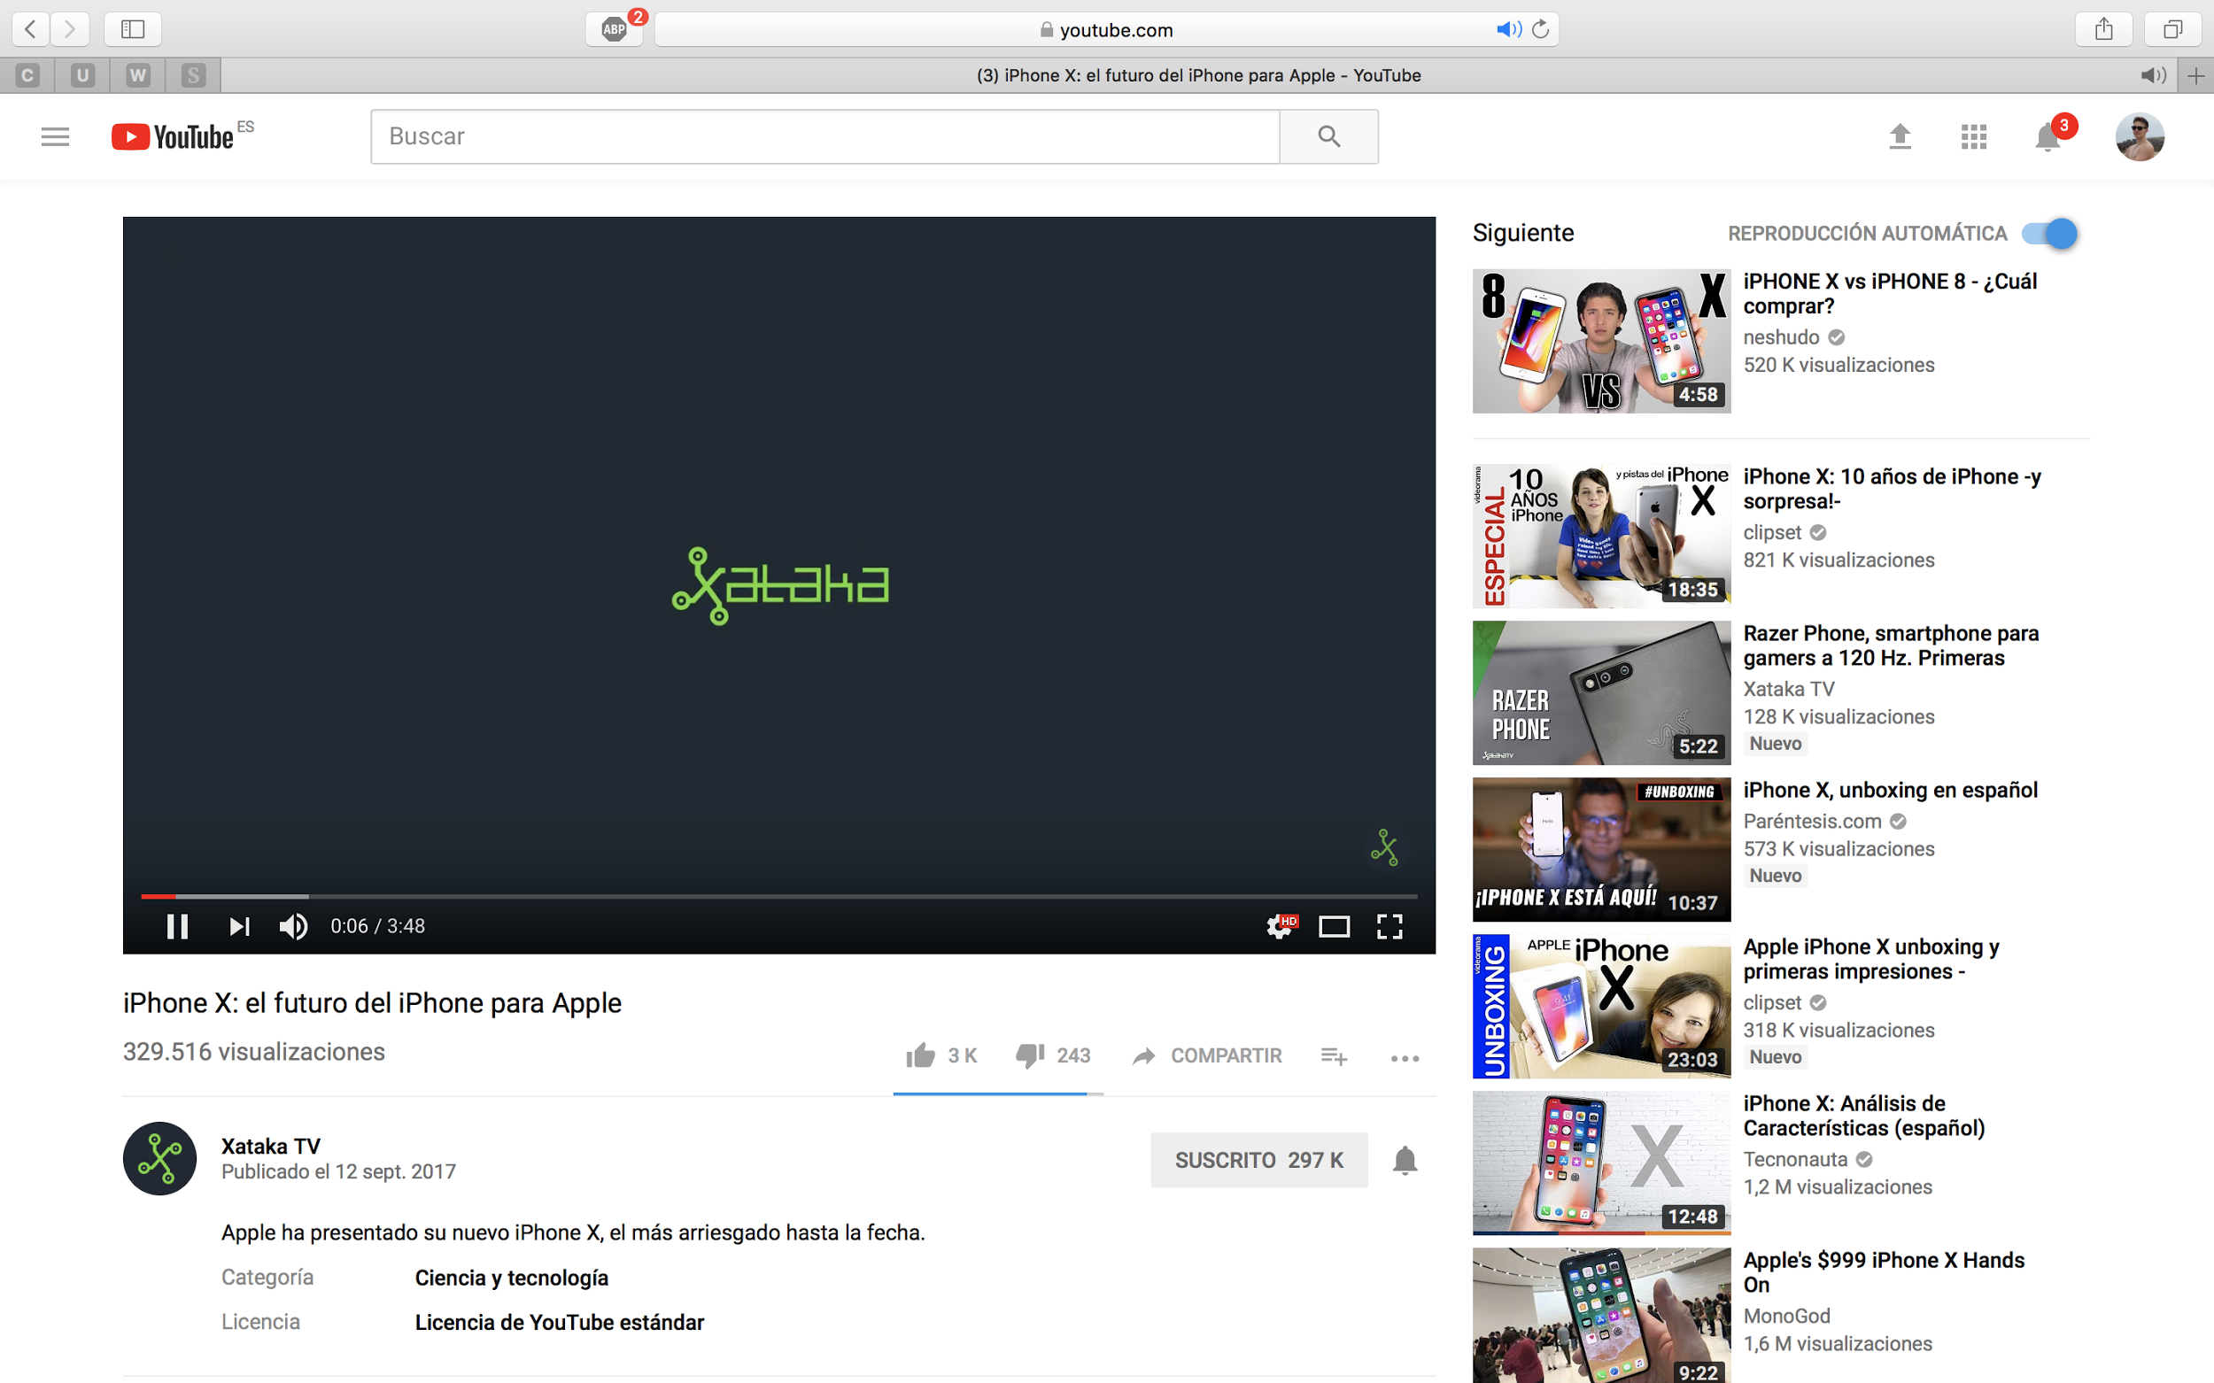

Here, we can see a bar inside the video player, which shows the photogram of the video we are placed in and the quantity of the total video which has been charged.

1. Match Between System and Real World

The system should speak in the same language the user does. Real world conventions must be followed, making information appear in a natural and logical order.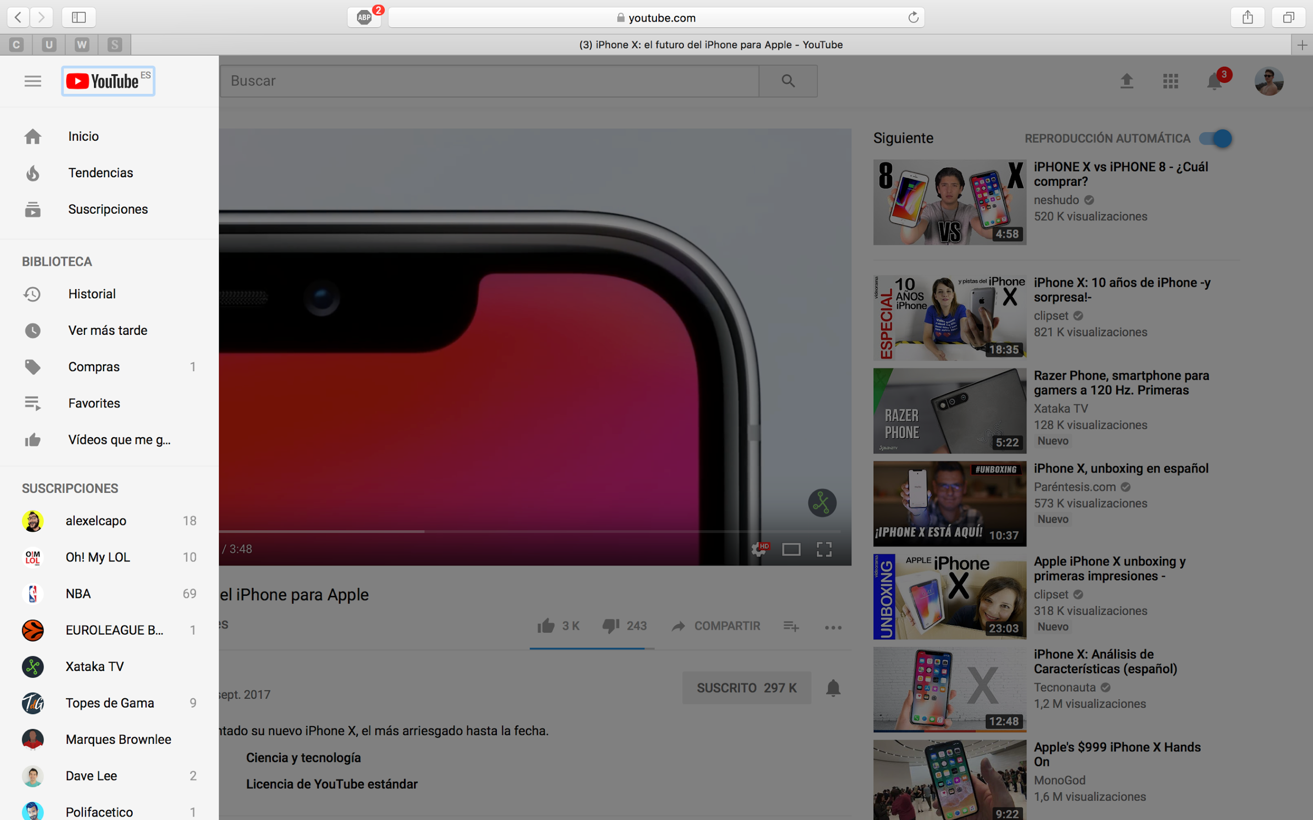

Here, we can see the different categories in the menu, appearing first the most used and important options, and sequentially, more specific options more related with the explicit user who is using Youtube, as bought videos or subscriptions.

1. User Control and Freedom

Users often choose functions by mistake and they need a clear exit, leaving the unwanted state without making any undesired change.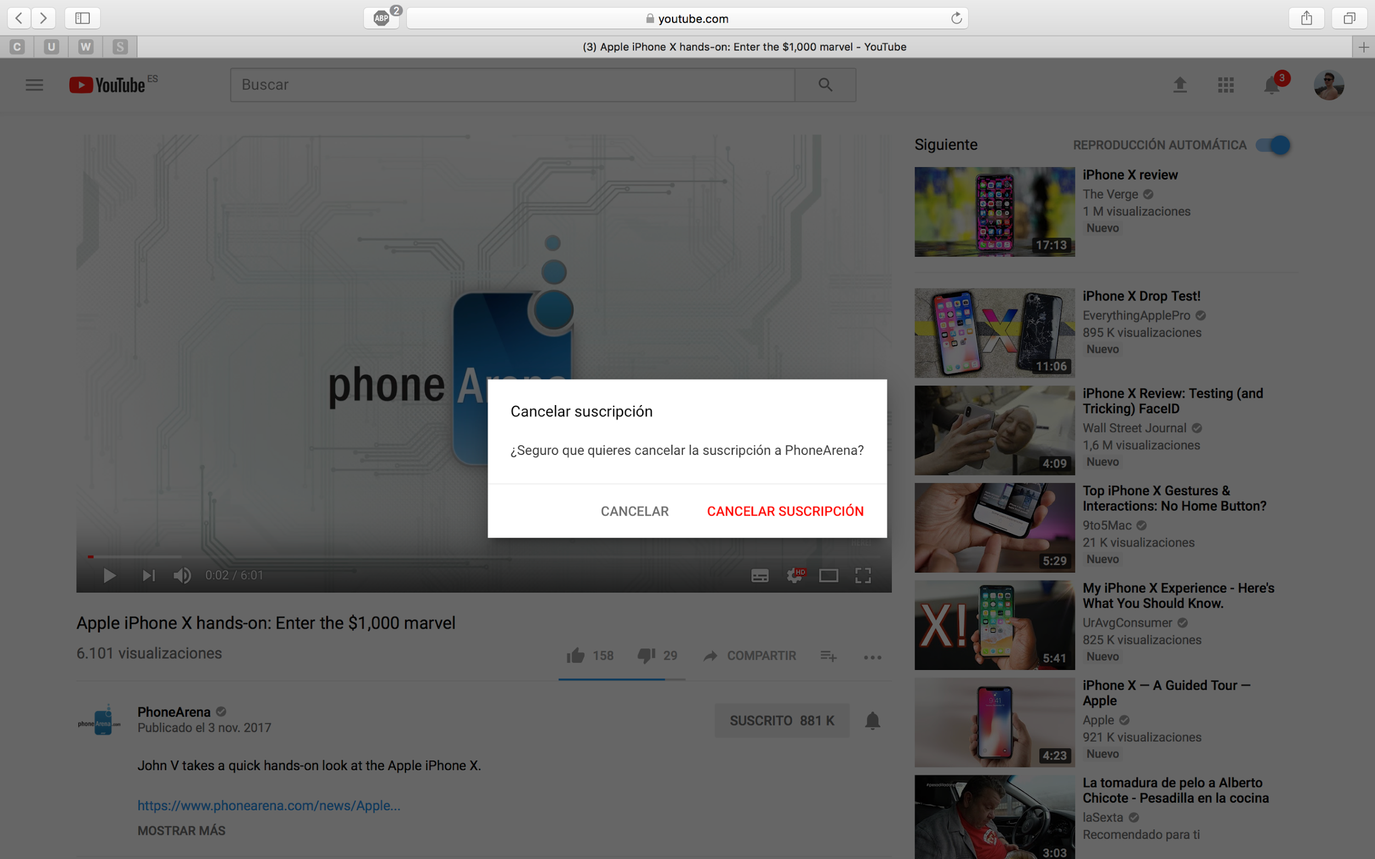

In Youtube, we can find that options related with subscriptions and purchases are always accompanied by a tuple accept/cancel, providing the user the option of avoiding the changes if the button was clicked by error.

1. Consistency and Standards

Users should not have to wonder with different words, situations or actions which mean the same. Platform conventions must be accorded and followed.

Here, we see that the format used to express visualizations, new content, likes, dislikes, trusted channels and subscribers is always the same, providing the user a clear experience and understanding of the site.

1. Error Prevention

Either eliminate error-prone conditions or check for them and present users with a confirmation option before they commit to the action.

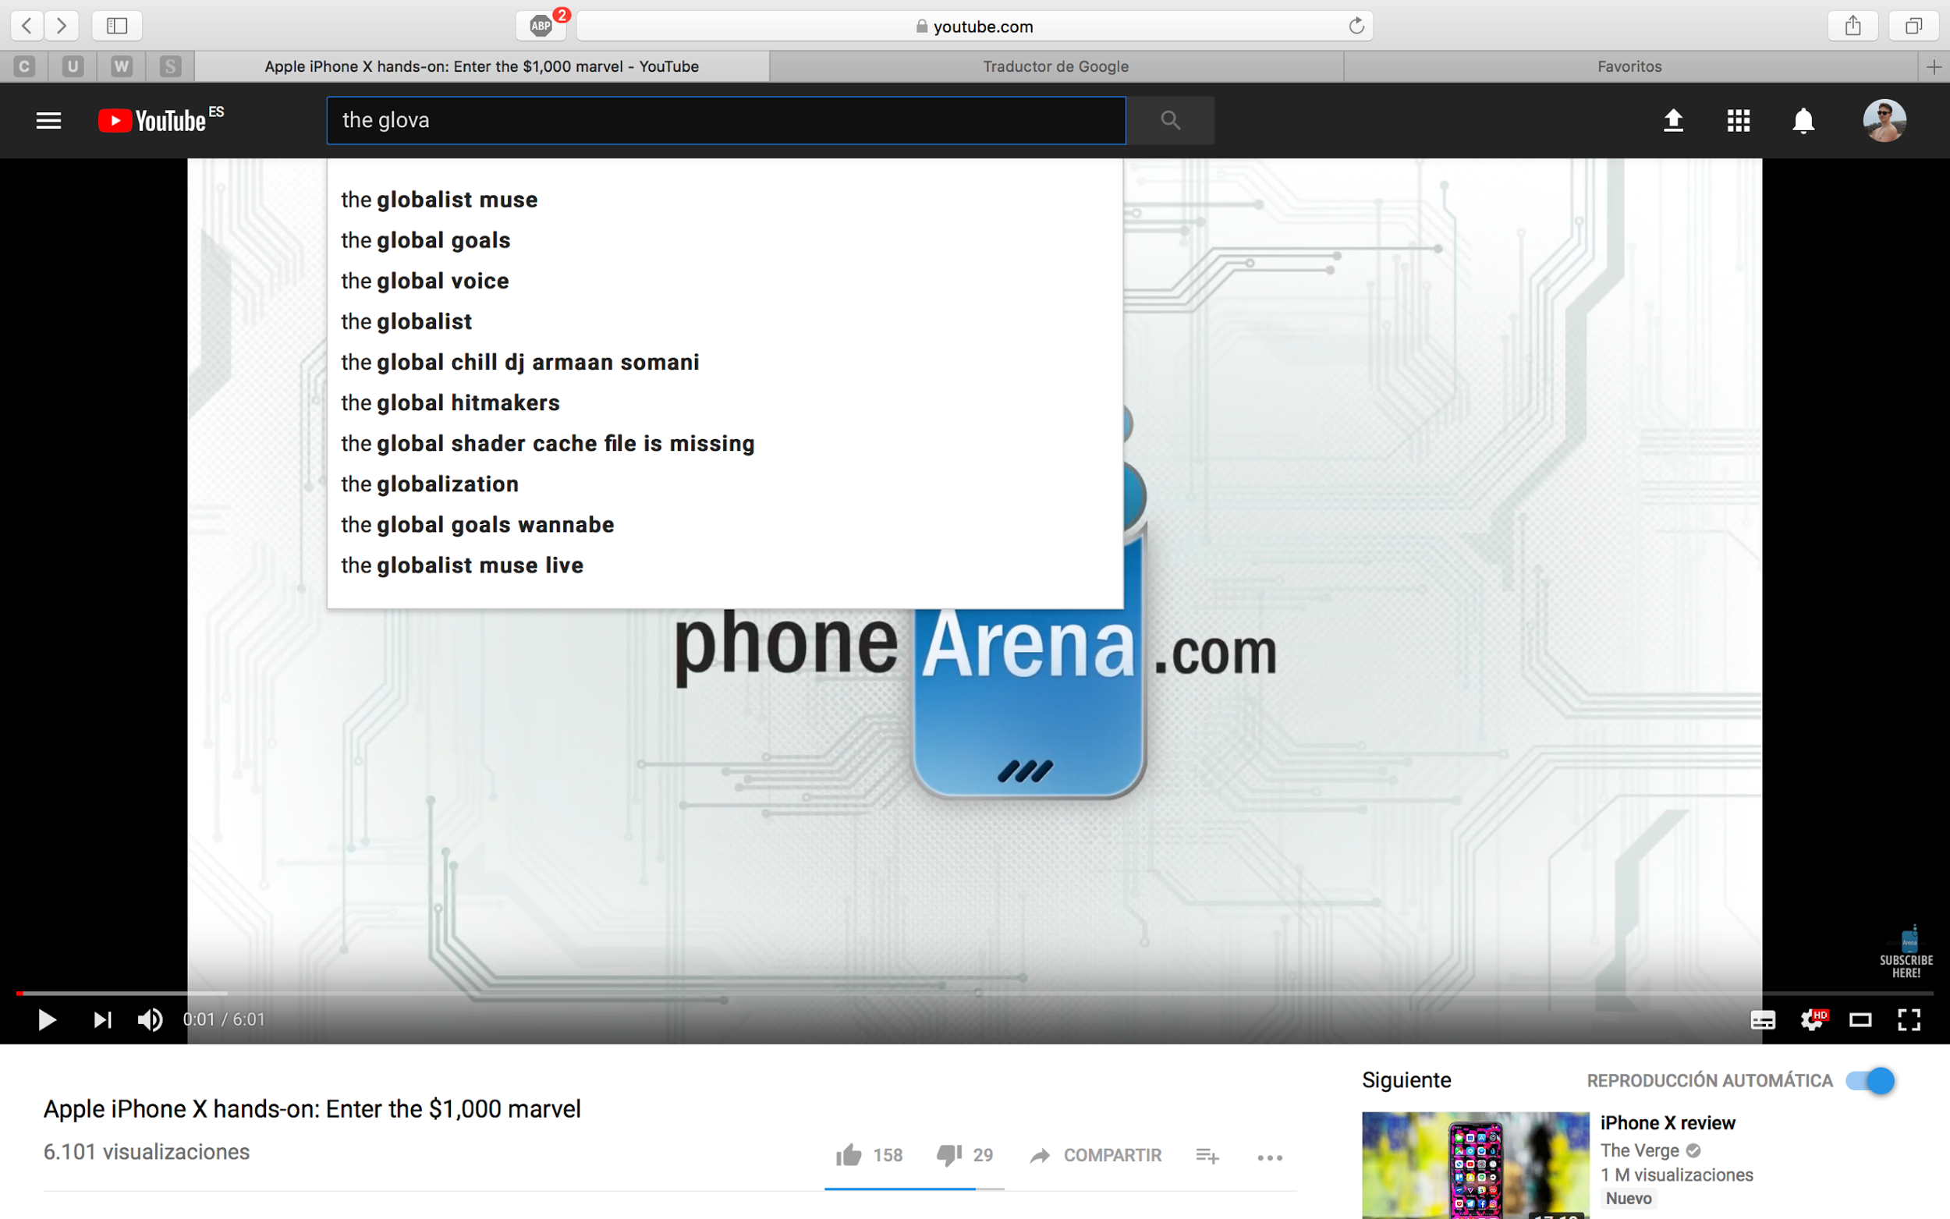

Youtube searcher provides a correction tool, returning the user the recommended results for the input he introduces. In this case, we are writing global with v, the searcher knows it and returns the results it considers are the most appropriated to the user’s input, but still gives the user the option of committing the input he has introduced in the search field.

1. Recognition Rather than Recall

Minimize the user’s memory load making the elements of the site visible.

Here we can see that when an option is selected, the color changes respect to the remaining ones, and also the selected option is expressed in each panel.

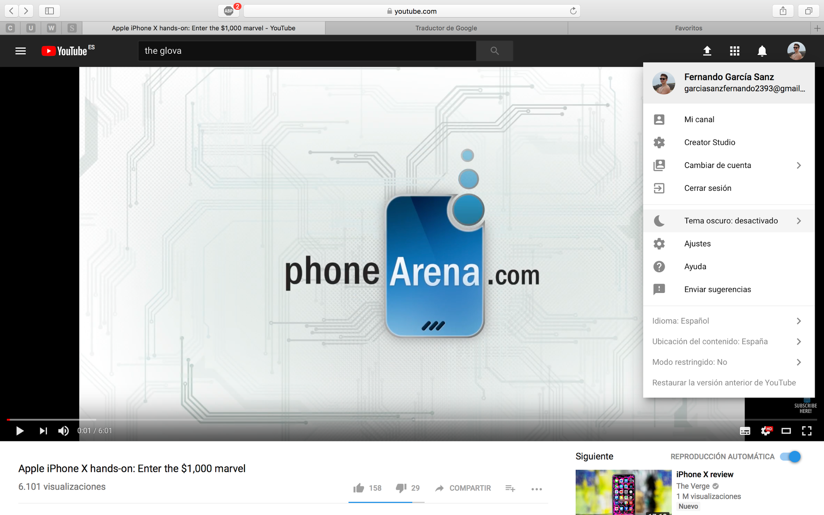

1. Flexibility and Efficiency of Use

The system should cater to both inexperienced and experienced users.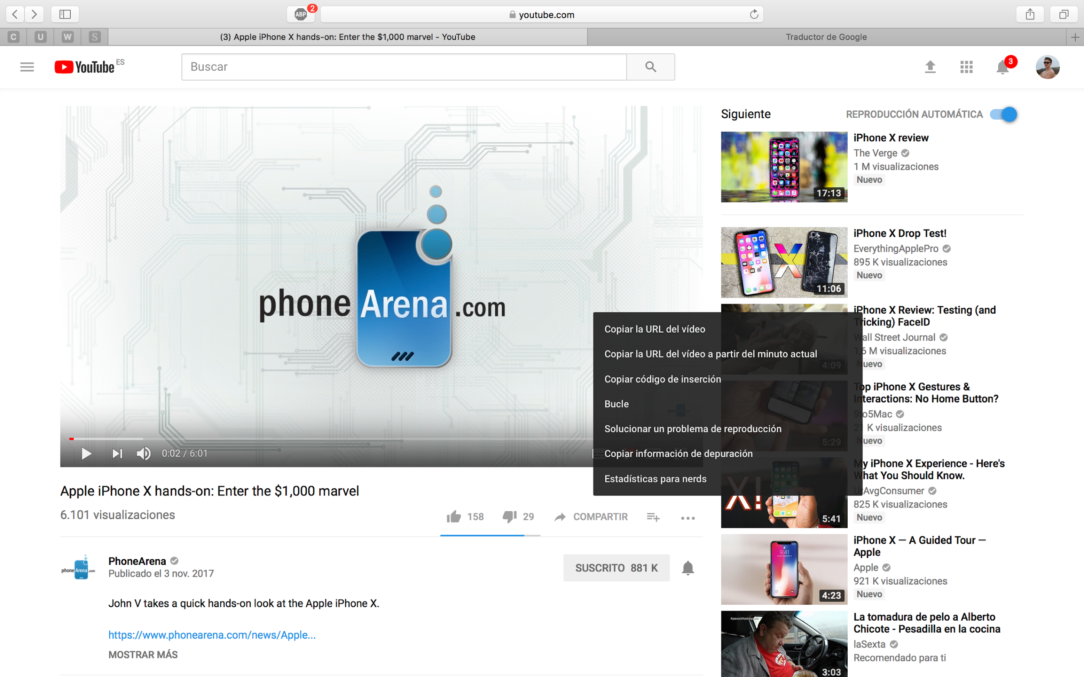

Youtube allows users to check the statistics of a video, play it in loop mode, copy URLs in different ways, solve playing problems and copy debugging information. Most of these options will be useless for the common client of the platform, but the most experienced users or some specific ones would maybe benefit from them.

1. Aesthetic and Minimalistic Design

Dialogues should not contain information which is irrelevant or rarely needed.

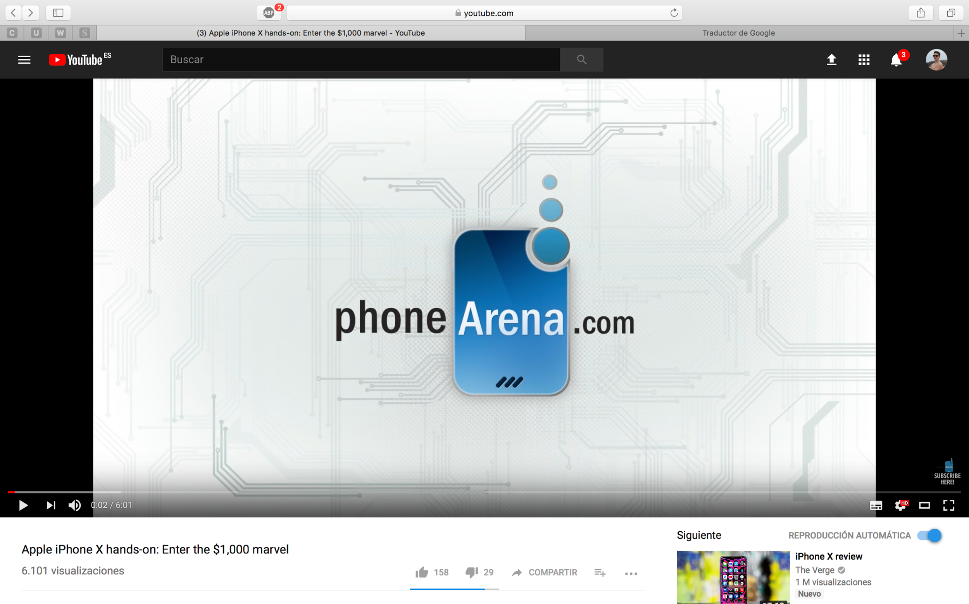

Youtube has an option which is called cinema mode, changing the format of the player and reducing even more any element which could provoke a distraction or a loose of space for the video, despite full screen mode is not activated.

1. Help Users Recognize, Diagnose and Recover from Errors

Error messages should be expressed in plain language, precisely indicate the problem and constructively suggest a solution.

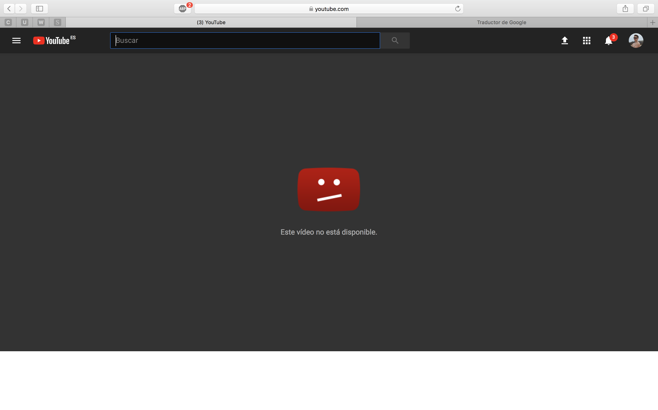

In Youtube, the main error is look for a video which is not available, because the channel has erased it or just because the video simply never existed and the URL is wrong. Youtube informs about it, but it is true that a solution is not given.

1. Help and Documentation

Help information should be easy to search, focused on user’s task, list concrete steps to be carried out and not be too large.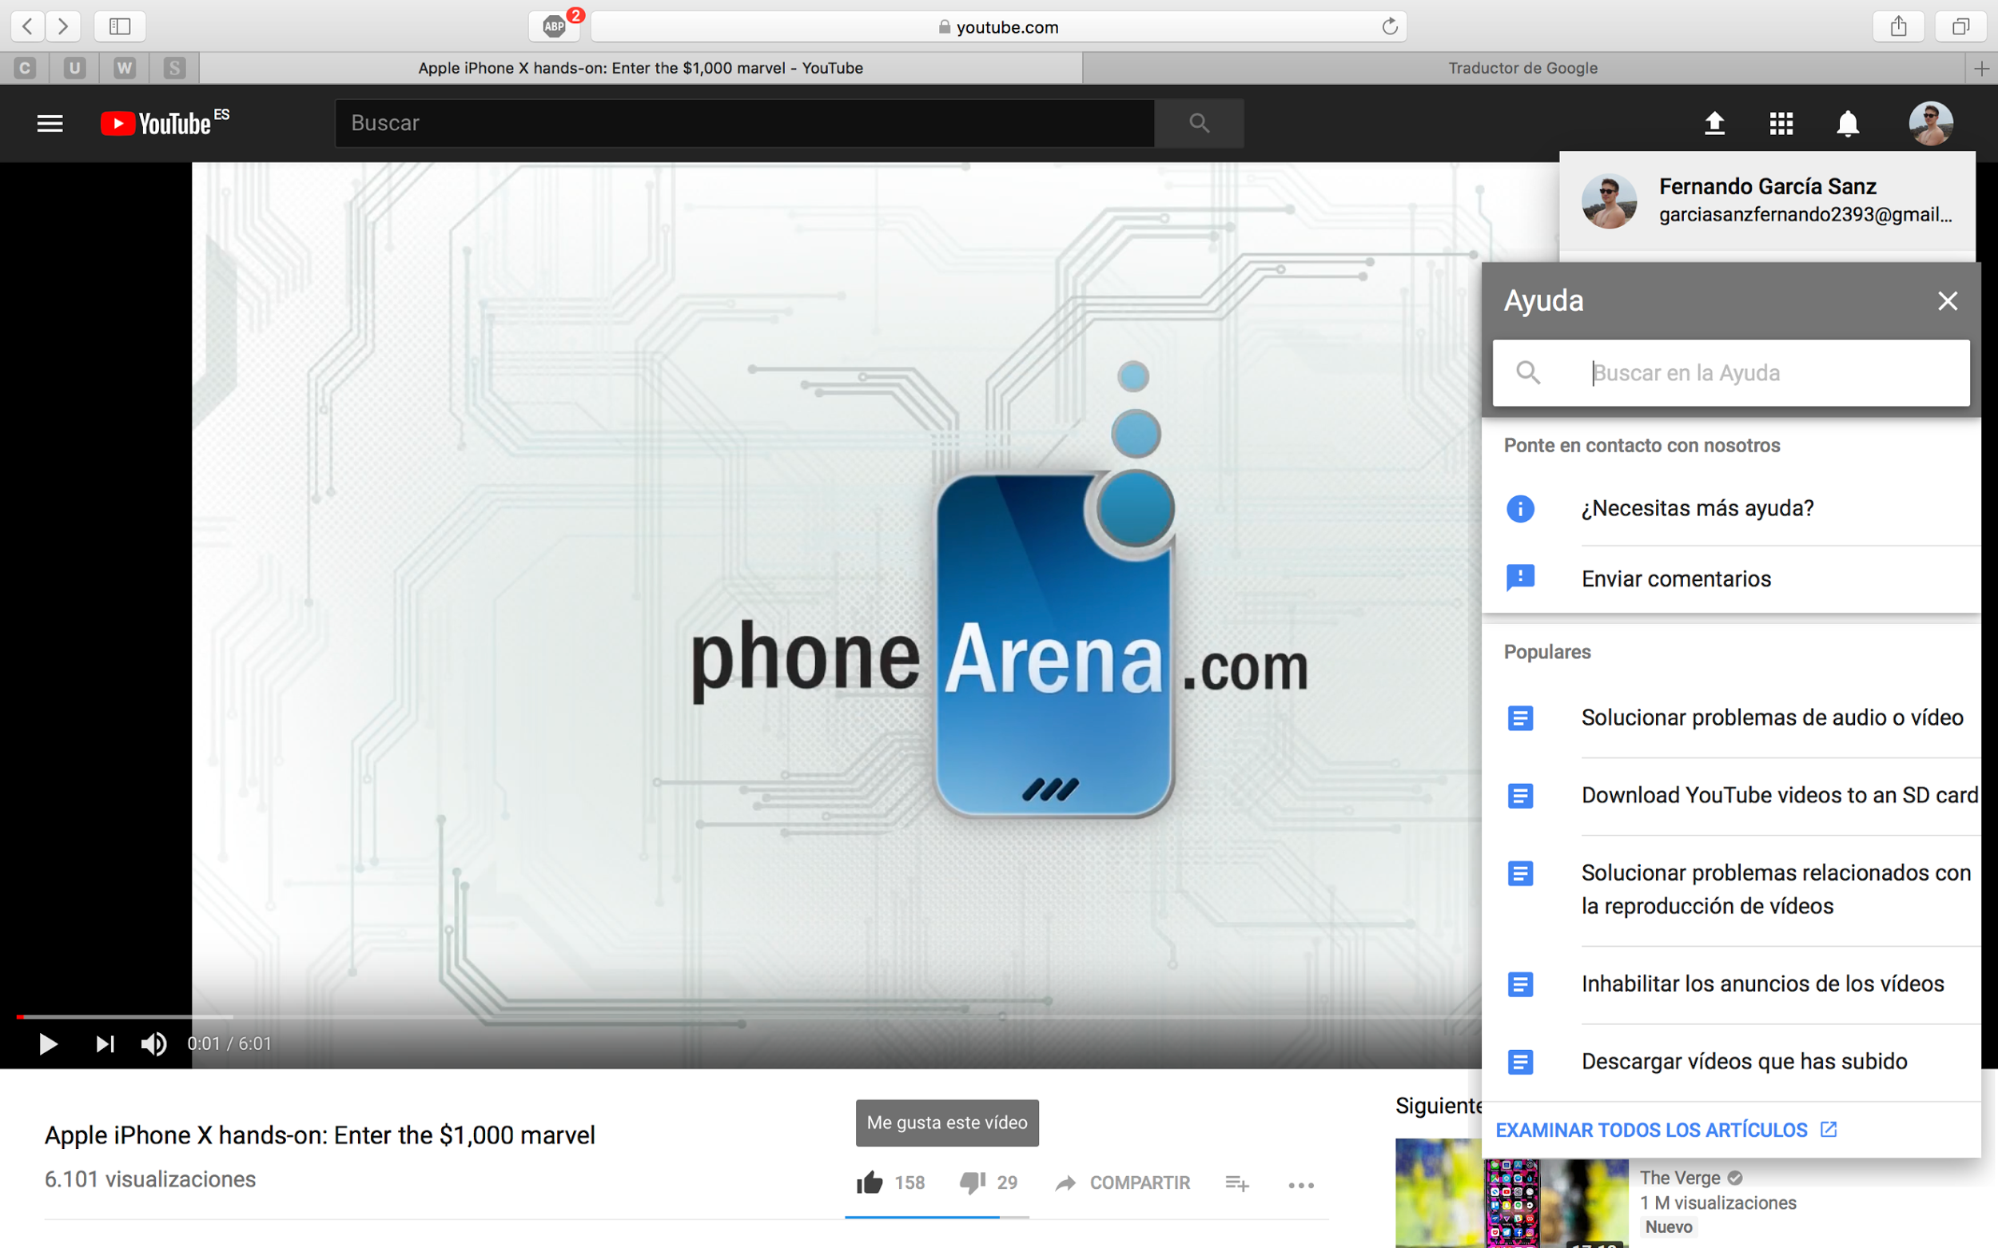

Youtube platform offers a help men u in which you can select any option of the ones displayed or look for the one which better adapts to your needs.

## Van Duyne Patterns’ Analysis:

Van Duyne Patterns explain the rules to follow to achieve a good website design. There are several rules to follow, and we can find the next one in this platform:

D1 - Page Templates:

A webpage must be consistent with its design. We can notice that Youtube is a good example of it, because for each of its billions of videos, the format of the webpage does not change.

E2 - E-mail subscriptions:

A company needs a way to keep contact with its users and maintain them informed. Thanks to Google accounts, for Youtube is quite easy the fact of contact the clients of the platform.

E5 - About Us:

For a company, it is important to explain which goal it is dedicated to. In Youtube, we are able to find information about the site, the creators, advertisement, developers…

E8 - Privacy Preferences:

Clients of a website need an easy way to access and change the privacy settings. In Youtube, inside the personal account sections, we can find one call privacy, which allows to manage this kind of settings.

H2 - Sign In / New Account:

A single process has to handle both returning customers and new customers. The lower the quantity of information about the client is stored, the easier creating new accounts become. Google, so Youtube, has an easy and intuitive process to change and create accounts.

H3 - Guest Account:

It happens that many clients may refuse to use a site if they have to create or spend time creating an account. The option of using a website as a guest is recommended to avoid this problem. Youtube allows to use all functionalities which are no related which recommendations and subscriptions to the user to anyone who access the site without logging in.

H4 - Account Management:

Customers usually need to manage the information a web page stores about them. Youtube allows the user to quickly access to his personal information and modify it if the client requests to do so.

H9 - Direct Manipulation:

Site customization, changing views, layouts… All these tasks may result difficult for the user. Youtube lets the user to change the webpage design theme, store videos to watch them later, stored the favourite content, etc.

H10 - Clear Forms:

Sometimes, when the user has to introduce data in a site, it could be frustrating, due to the format, the quantity of data required… Providing short and well-built formularies is a good idea to avoid it. Youtube requires few information, and thanks to Google accounts, these data can be easily modified and updated.

H11 - Predictive Input:

Filling forms and fields may become a tedious task. Google autocomplete functionality and the predictive searcher of Youtube are a great solution to avoid this kind of frustration.

I2 - Above the fold:

Customers sometimes loss information if they have to scroll down to visualize it completely. It is ideal to show all the important information at the top of the page. Youtube shows the most popular content and the new one first, giving you more possibilities about visualizing it.

J1 - Search Action Module:

Users usually want to swiftly jump from one point of the site to other. The searcher is in charge of this task. Youtube searcher allows to group up the content of the site according to diverse classifications: content, channels, words, date…

J3 - Organized Search Results:

Sometimes it is difficult for visitors to understand the content coming from a search. Youtube displays the content according to the affinity with the user search, making easier to understand the content.

K4 - Action Buttons:

It is a good idea for making a website intuitive to user buttons to represent actions. Youtube provides different visible buttons to perform the main actions, like subscribing to a channel, uploading content or change the section the user is located on.

K11 - Familiar Language:

Unfamiliar terms may provoke navigating in a website becomes a difficult job. Using common language which most users understand may attract more visitors and make easier for them to empathize with the site. Youtube presents a colloquial language, with no technicalities or strange words which may become navigation into a hell.

# Twitch:

Twitch is a web site dedicated mainly to play live videos of any kind of videogames, although now this principal idea has been expanded to a wider environment, reproducing also live streams of more kinds of contents, such food, anime, etc.

It allows user to watch videos for free, but if a user wants to subscribe to a streamer, he has to pay a monthly fee and then, he will be notified of the channel updates and will have preference in many activities and access to premium services.

## Nielsen’s heuristics:

1. Visibility of system status:

A confirmation message is displayed when the registration has been completed.

1. Match between system and the real world:

The shop section follows user natural language as well as the registration/accessing section.

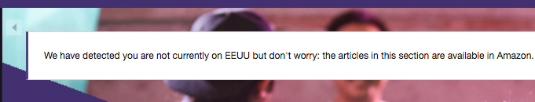

1. User control and freedom:

None visible.

1. Consistency and standards:

The name standards are followed in every moment. In the explore section, there are different types of content to browse. When searching, the suggestions given by the web follow the same standard types of the explore section.

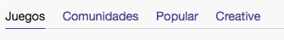

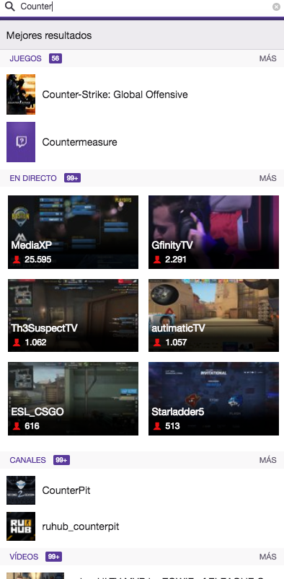

1. Error prevention:

There are confirmation and cancel buttons for the registration/access.

The suggestions displayed when using the search bar present information to the user in order to help them correct errors.

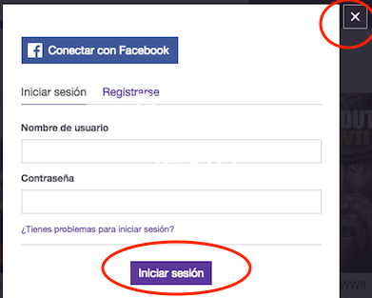

1. Recognition rather than recall:

Twitch helps the users recognize where they are, as it displays in every moment the path from the initial page.



1. Flexibility and efficiency of use:

None visible. They could implement a floating window in order to directly subscribe to the channel of a video instead of having to first enter the channel and then click on subscribe.

1. Aesthetic and minimalist design:

The games and communities are displayed only showing their corresponding portrait and name in order to simplify the design.

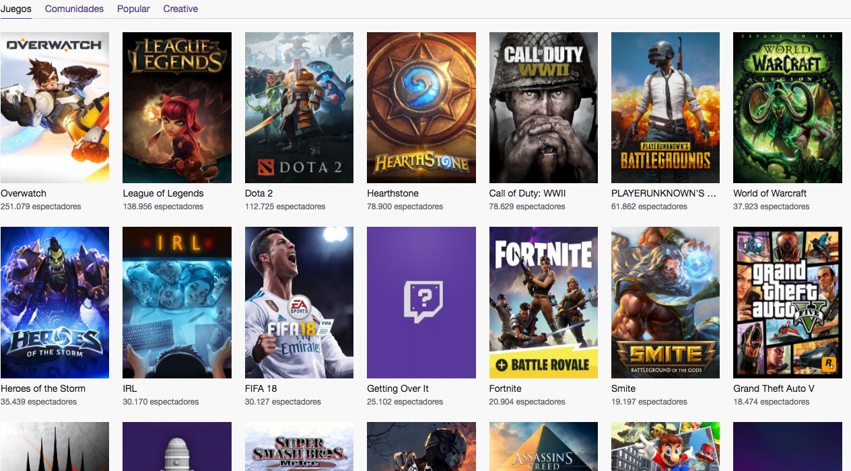

1. Help users recognize, diagnose, and recover from errors:

In those cases when a field of a form is not valid, the concrete problem with the field is displayed.

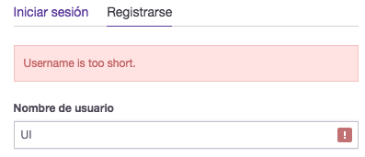

1. Help and documentation:

The web offers help in case the user has forgot the password.

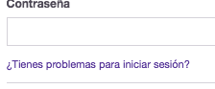

## Van Duyne’s design patterns:

B1- Multiple ways to navigate:

Browse and search on top of web



B2- Browseable Content:

Content in categories and highlight of current category

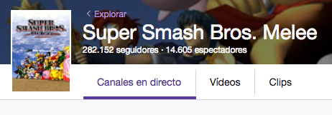

B7- Popularity based organization & B8- Category Pages:

A whole section dedicated to videos sorted by popularity.

Categories well differentiated and with consistent layout

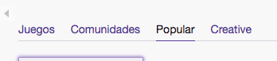

C2 - Up-front value proposition:

Twitch relies mainly on game streamings so in the home page, a video streaming is automatically displayed. In this way, the user instantly has de idea of the page.

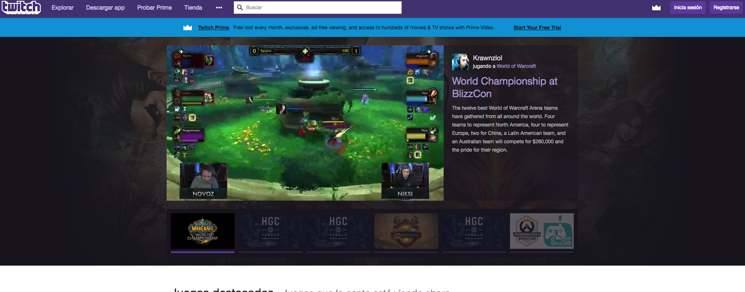

D4 - Personalized Content:

A lateral section is dedicated to personal channels and videos of the user. If the user has not signed up, the section displays a message encouraging so.

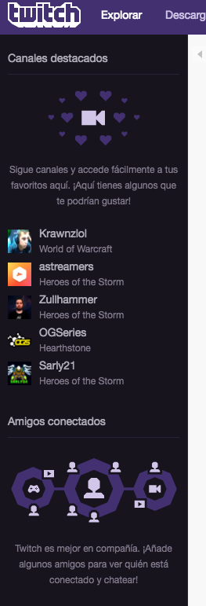

E1 - Site Branding:

The style is consistent along the web page and is differentiated from other famous webs (the purple color is always dominating). The logo is always on top-left corner.

E5 - About Us:



H4 - Account Management:

All info can be seen in a tab of the configuration of account section.

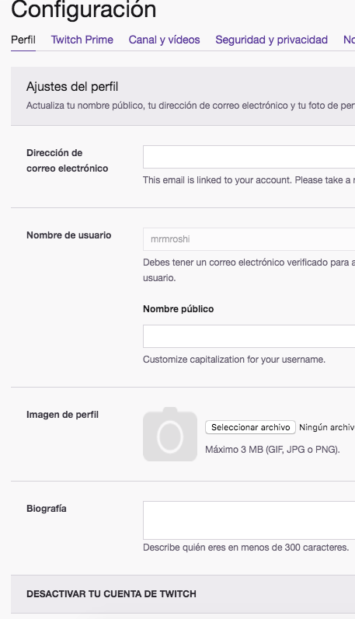

J1 - Search Action Module:

The search bar allows to identify different categories of content in the suggestions while the user is writing (instead of allowing to search a term directly in a category of content).



K1 - Unified Browsing Hierarchy

The main categories of content are directly shown in the explore section.



K6 - Location Bread Crumbs

The path with respect to the home page is always shown (although the web is not very deep).



K11 - Familiar language:

The web uses natural language to communicate with the user.



# Netflix:

## Nielsen’s heuristics:

1. Match between system and the real world:

The system communicates with users by means of real-life human expressions.

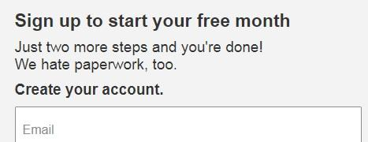

1. User control and freedom:

None visible.

1. Consistency and standards:

The web follows rigorously the standards for the names of the categories.

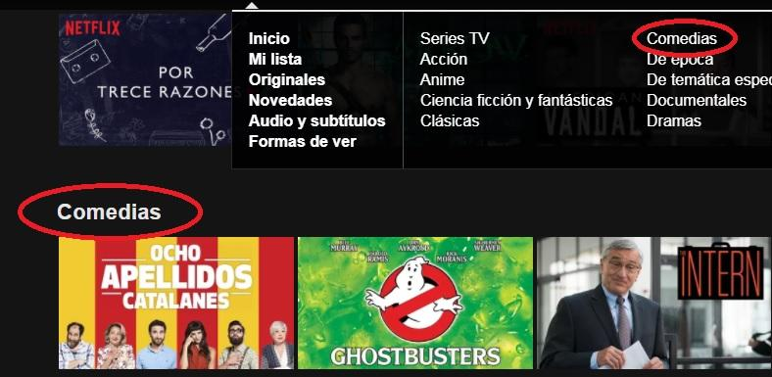

1. Error prevention

There are submit (or save) and cancel buttons as well as suggestions implemented in the search bar in order to guide the user.

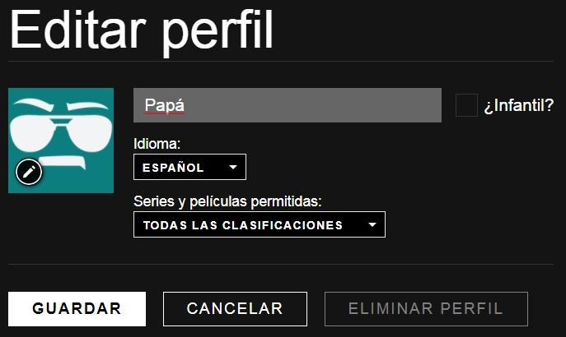

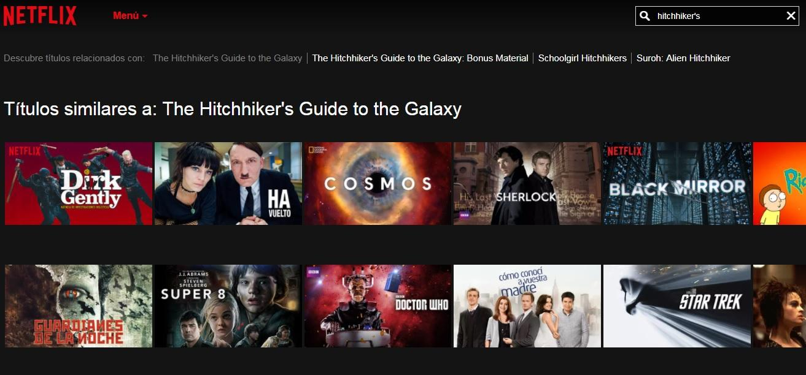

1. Recognition rather than recall:

The web helps the user visualize the actions using the titles and icons. In the menu section, an arrow pointing down is displayed in order to tell the user that the menu is displayed below when clicking on it.

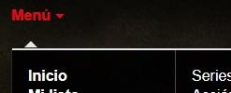

1. Flexibility and efficiency of use:

Netflix allows the user to set a Children Mode for the users. Such type of profile allows the user to have a dedicated profile for the Children using the account instead of having to look for children content every time they want to stream some movie or series for their children.

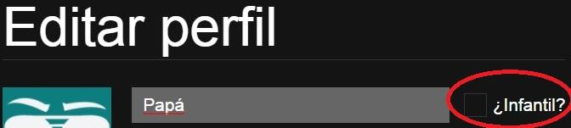

1. Aesthetic and minimalist design:

The home page shows different movies or series. It follows a minimalist design. consisting of two main design elements: only the covers of the different titles are shown (no name or description) and they are divided in categories only identified by the name.

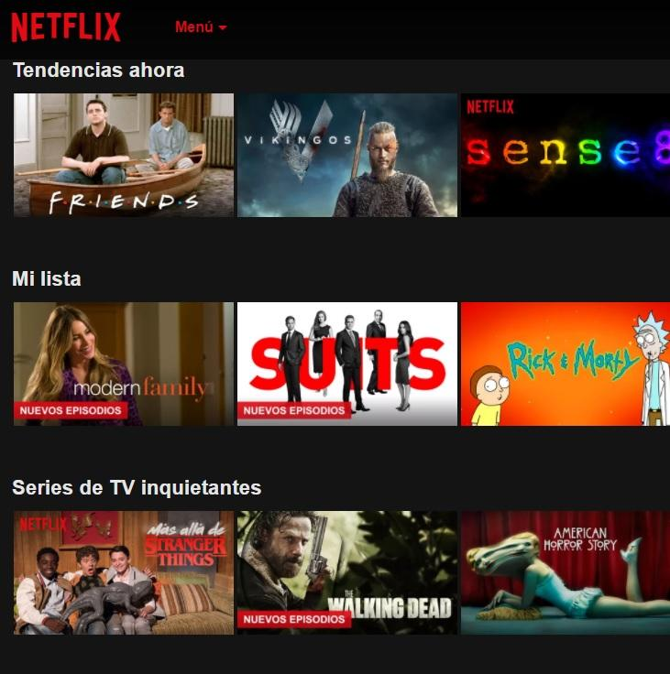

1. Help users recognize, diagnose, and recover from errors:

The streaming errors are identified with an error number, but the field errors are specified when displayed.

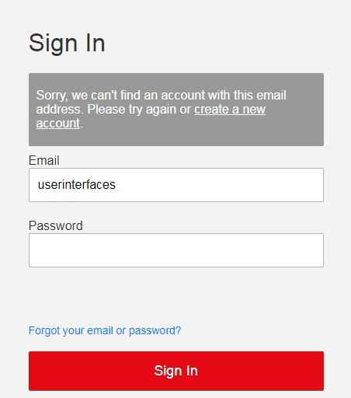

1. Help and documentation:

The help provided by Netflix is a section dedicated to it, but it does not provide punctual help in the form of buttons or floating windows as could be expected.

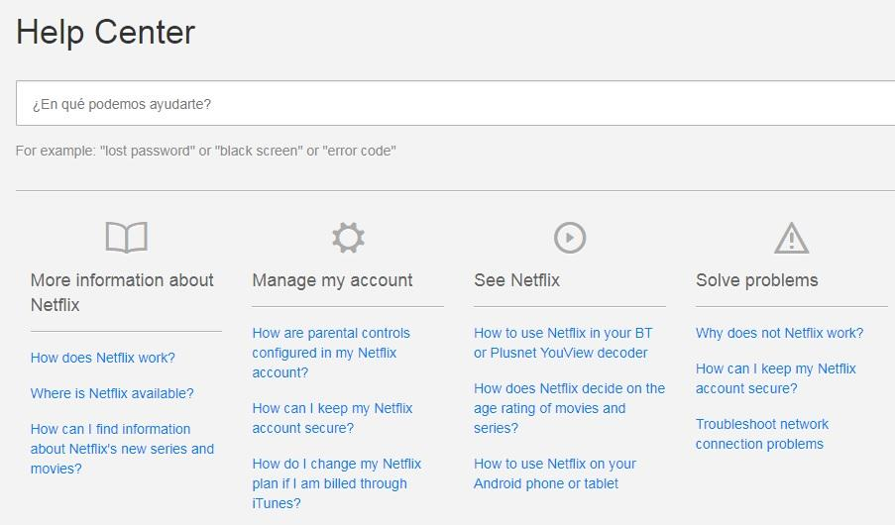

## Van Duyne’s design patterns:

B2 - Browseable Content:

The content must be clearly divided into different categories to ease comprehension. The web must tell the users where they are according to the hierarchy. In this case the categories are clearly divided and shown. Regarding the hierarchy, when the users access a title, it simply expands (on the same page) therefore, the users know in every moment where they are.

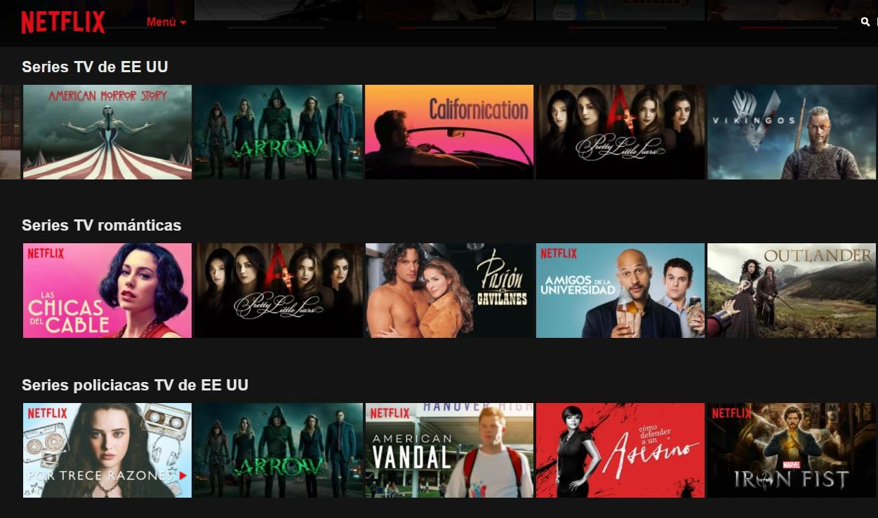

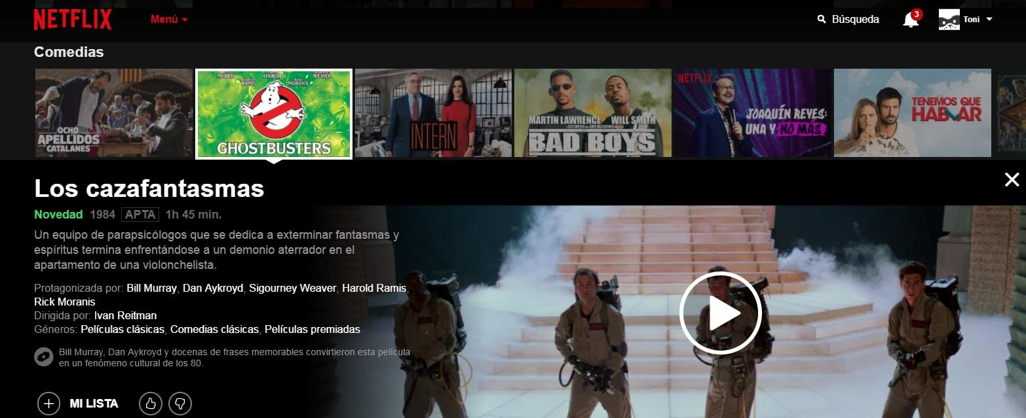

D4 - Personalized Content:

In order to provide personalized content is important to avoid being intrusive. Provide content that might interest the users based on the areas of the site they visit more. Also, dividing the content in categories is a good practice. Netflix achieves so by using an algorithm based on the titles viewed by the users. The content is divided into different categories which are constantly updated by Netflix including some which are purely based on the users’ tastes (according to what they watch).

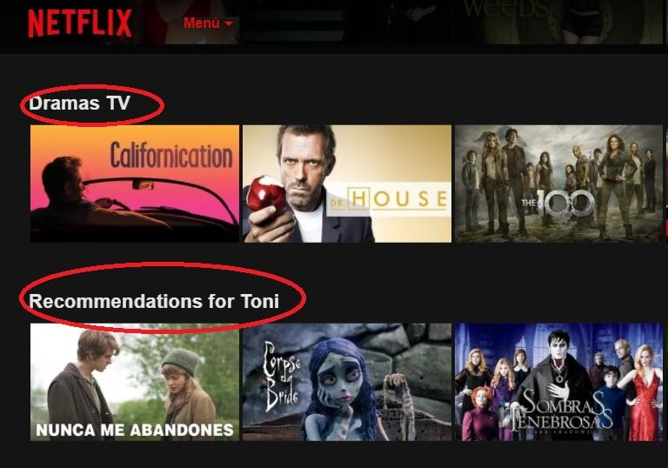

E1 - Site Branding:

It is important to make the users feel safe while browsing the site. Also, it is important that our site has a strong brand and is differentiated of other similar products. Netflix has very strong marketing. The site has a unique style which is easy to recognize by any user instantly. The logo is placed in every moment (except when streaming content of course) at the top-left corner.

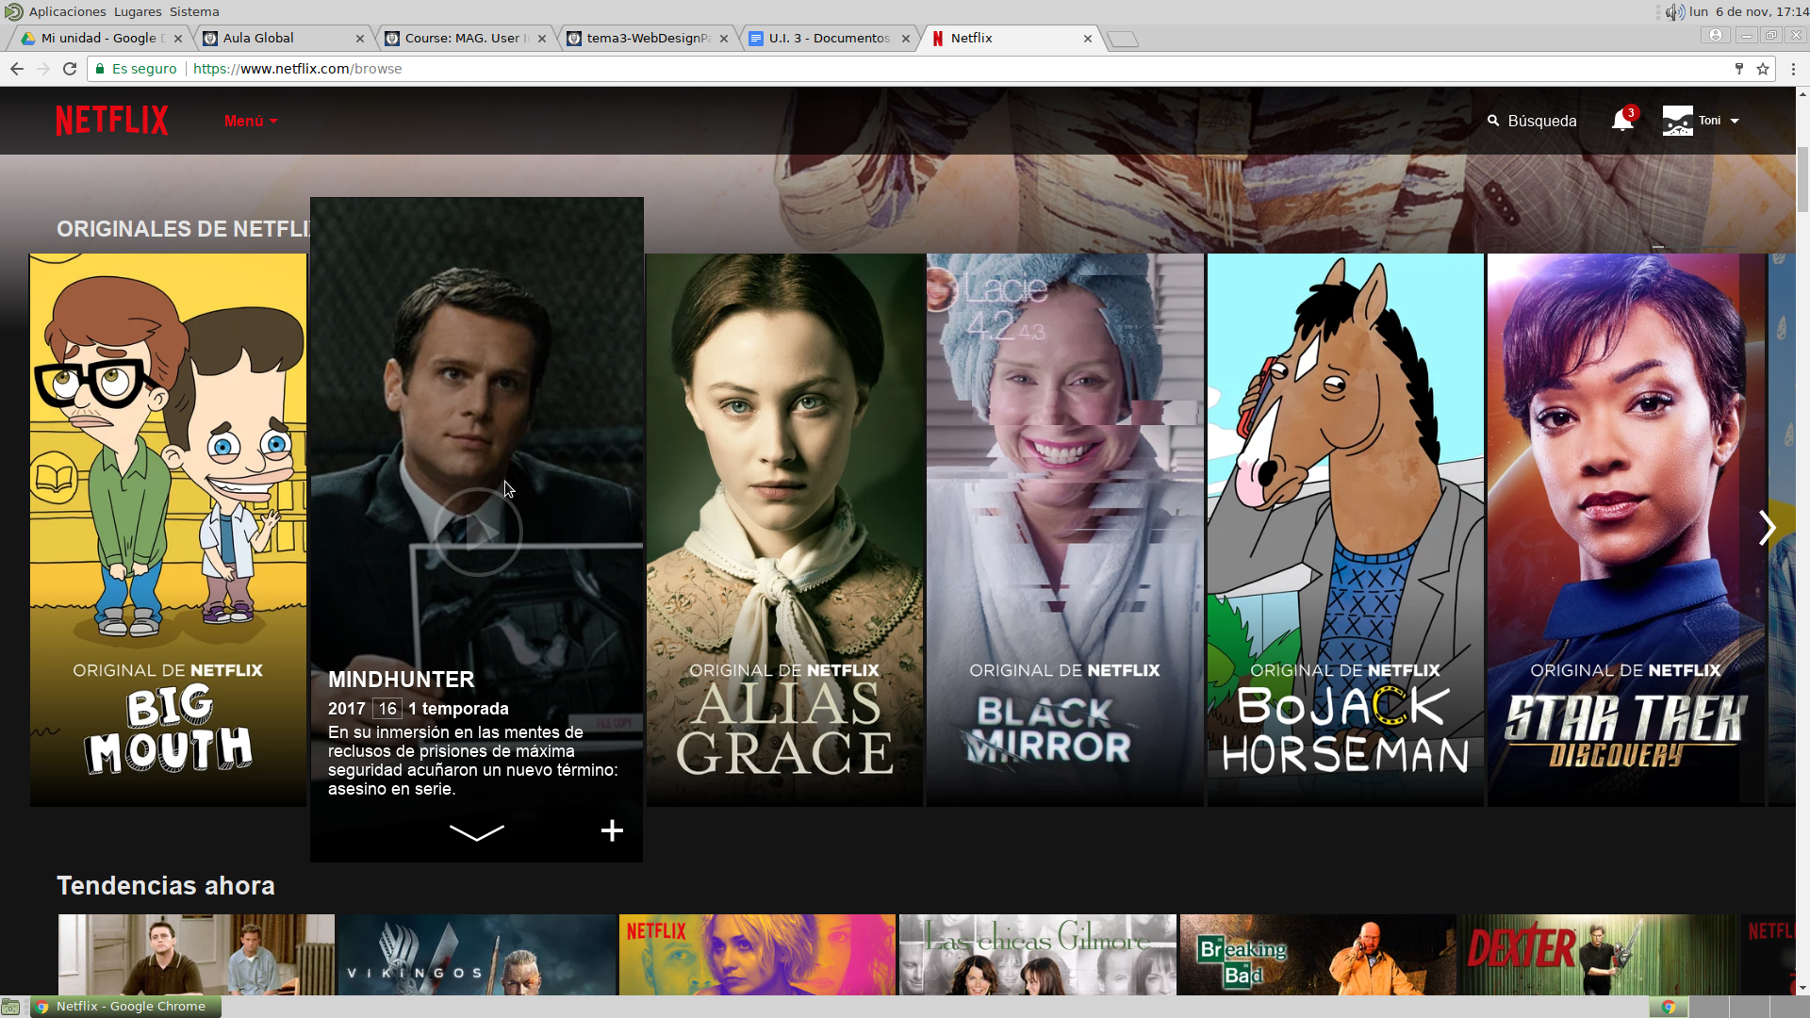

H6 – Floating windows:

In order to maintain context when browsing Netflix, a floating window has been used to show the menu. This helps the user to keep the main page where all the categories and titles are displayed and which is a key point in Netflix’s site.

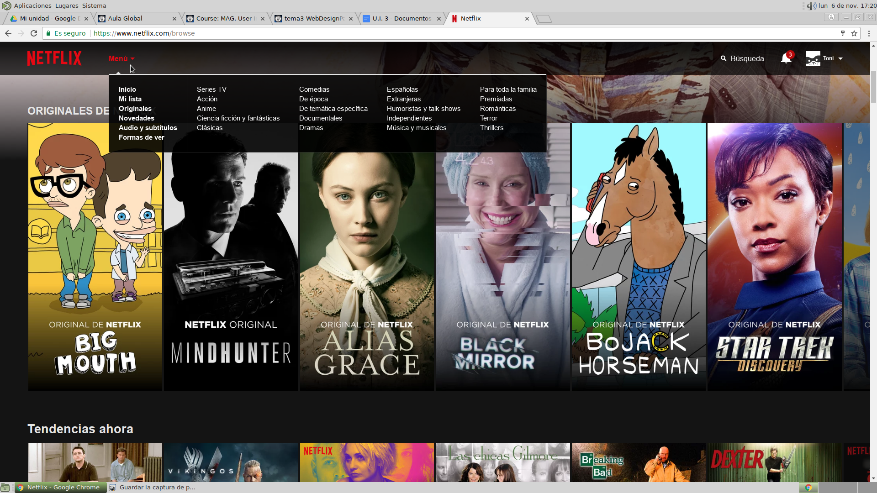

H11 – Predictive input:

The search bar of the site has a predictive text input field. The search goes one step further than usual predictive search bars, this one, shows directly the titles of the suggestions proposed, so it does not only suggests but also performs the search and shows dynamically the results.

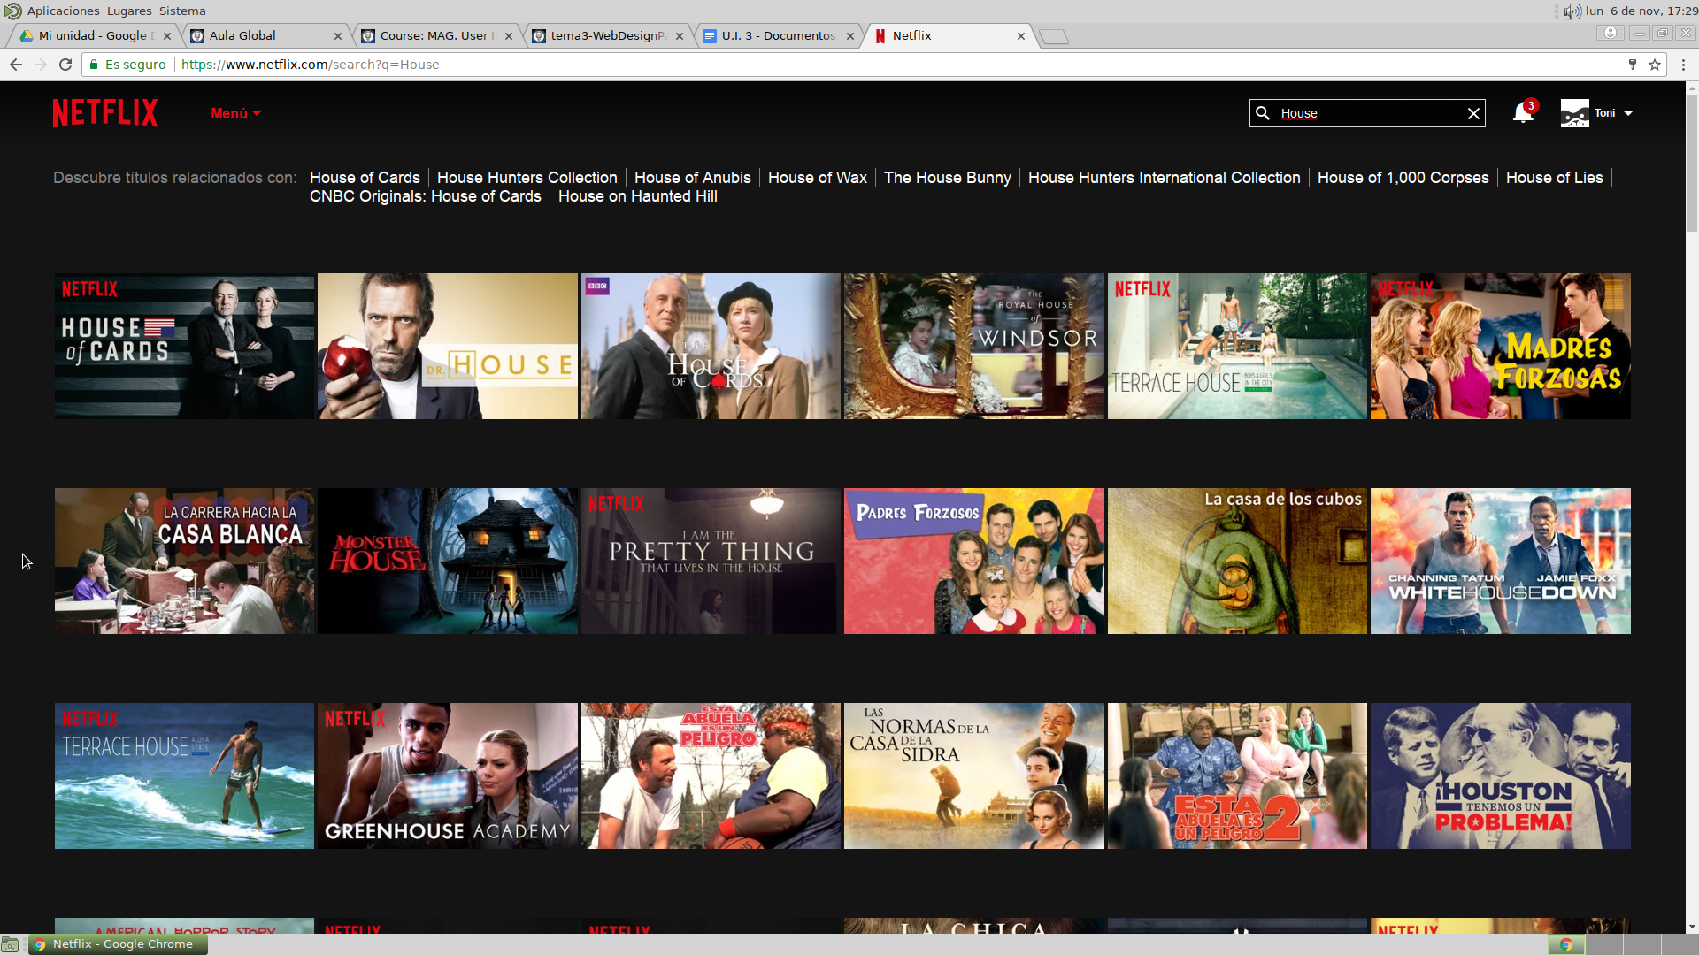

I2 - Above the fold:

The organization of the content is important, but it has to be visible to the users as well, otherwise it won’t be useful. That’s why Netflix groups all the important information on top of the page, in a fixed header which stays in the page when the users scroll down.

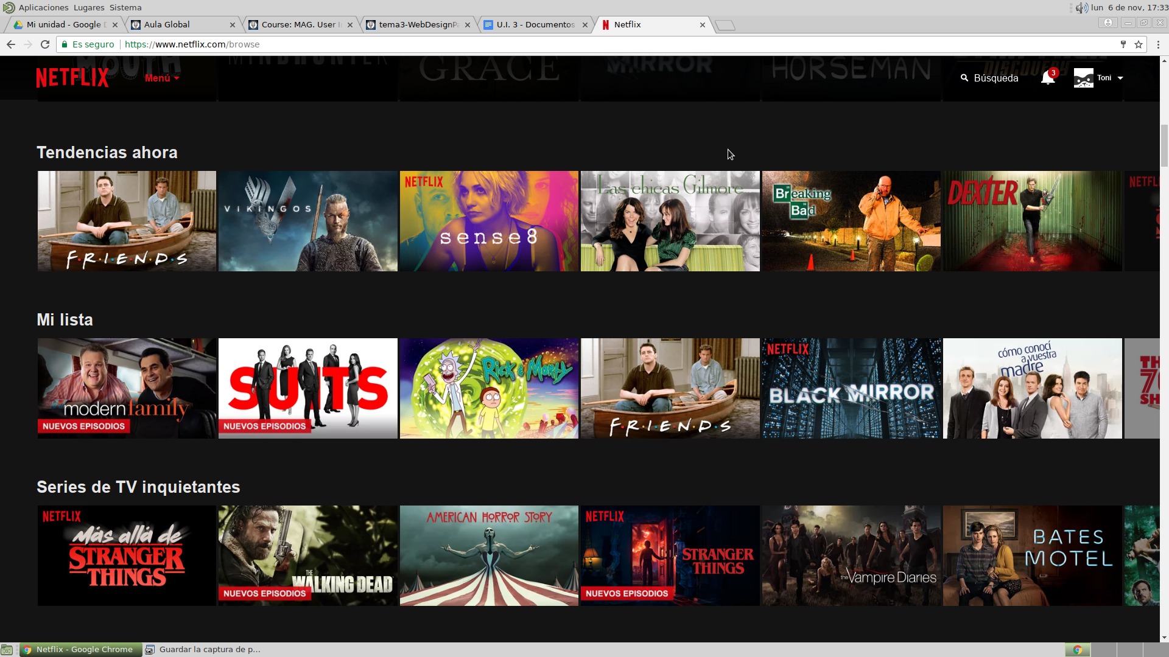

K4 - Action Buttons:

Sometimes hypertext links can be counterintuitive and even more nowadays since we are used to visual elements due to the increasing in use of smartphones. Netflix provides buttons with icons to perform many actions, the most remarkable one is the play button.

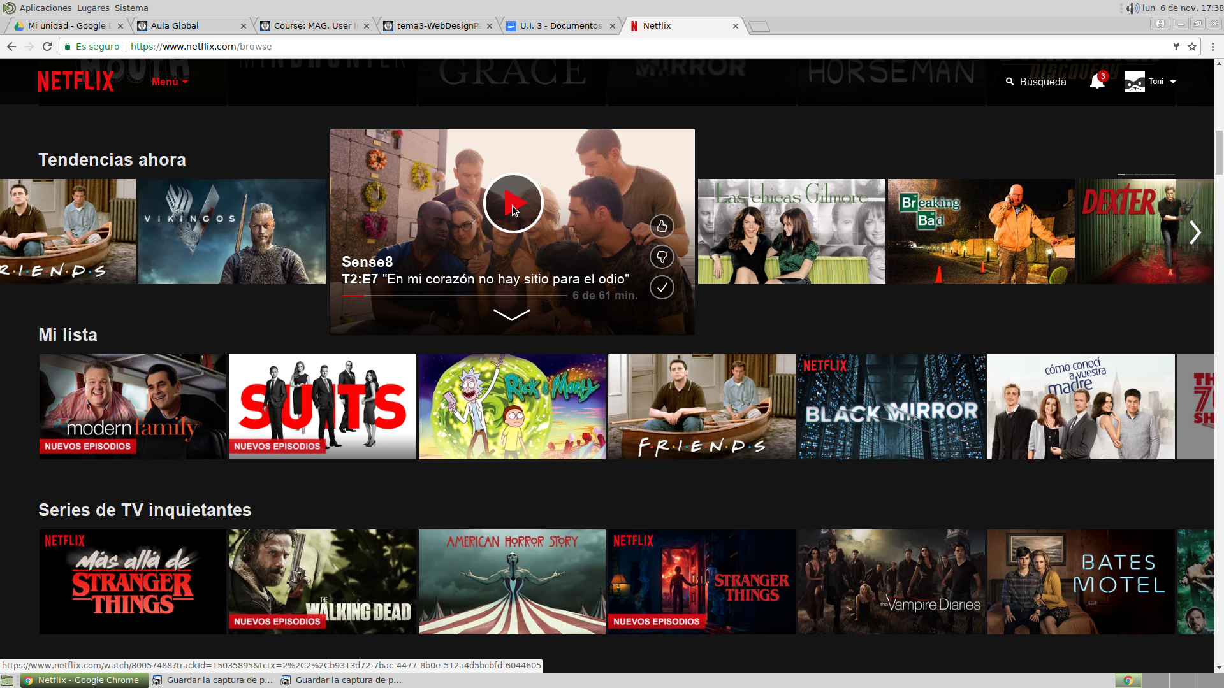

K11 - Familiar language:

The way to address the users is key to make them feel comfortable. The way Netflix achieves so, is by using common expressions when referring to the content (in categories or in lists).

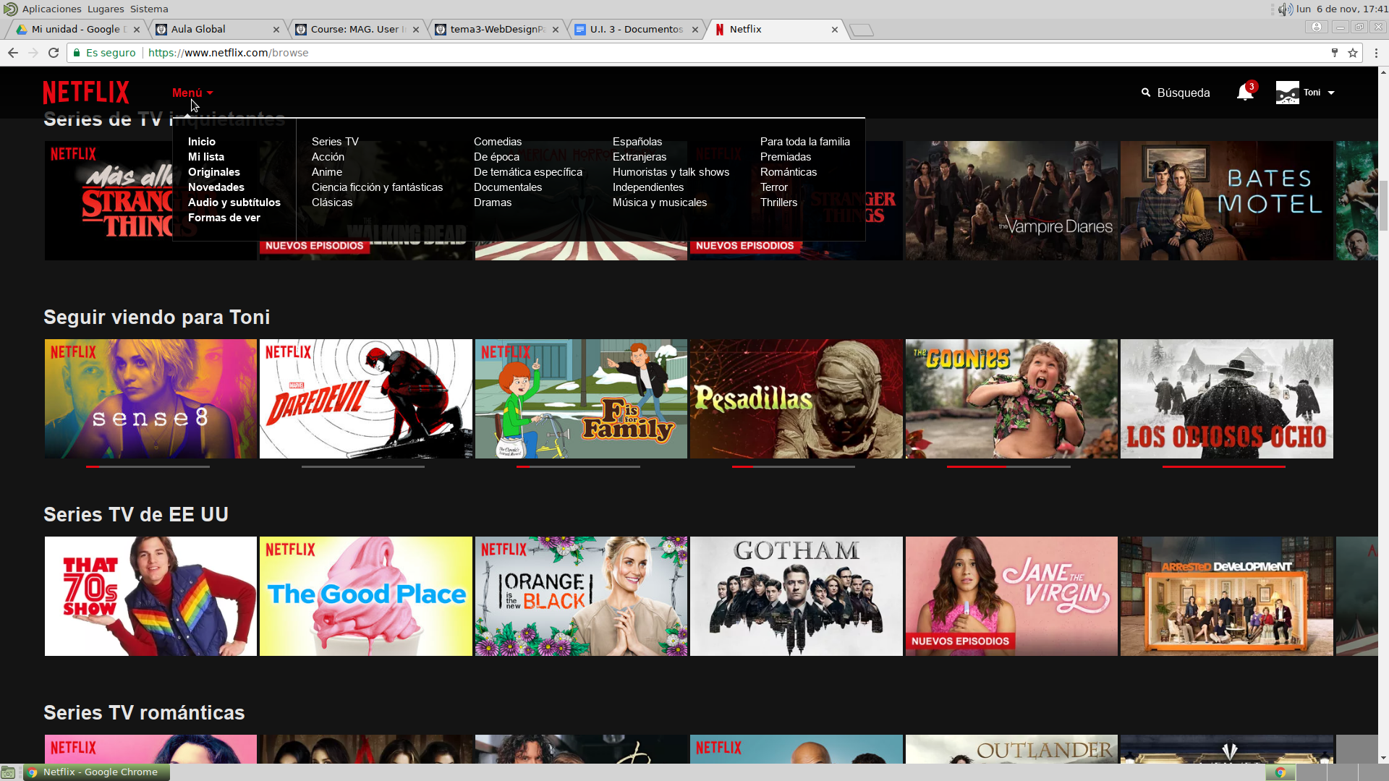

(For the whole family, Awarded, Romantic, Terror, Thrillers)

L5 - Reusable images:

In order to enhance the loading of the site and to reduce waste of resources, Netflix reuses images of titles when they appear on different lists (but that are on the same page).

# OUR WEB:

## Main Goal:

Our web page is aimed to provide online streamings of movies and TV series available in our wide catalog. The objective is to provide to our users an entertaining tool which is always at their disposition and control, regardless of the day or the hour we are there for you.

## Functionalities:

The functions of our web page have been inspired in the Nielsen heuristics and the Van Duyne Patterns. The webpage has also taken as reference the web sites we have analyzed to achieve the best performance in its field.

According to the Nielsen Heuristics, our page follows the next rules:

1. Match Between System and Real World:

The system should speak in the same language the user does. Real world conventions must be followed, making information appear in a natural and logical order.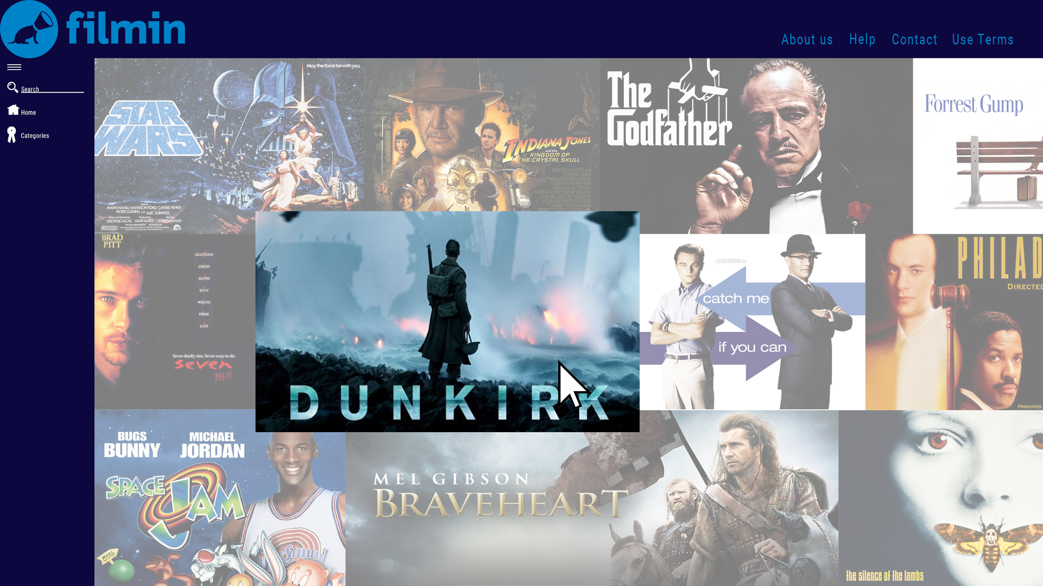

We can find in our web page different categories, home button and a search field. In the header also appear a link with information about the company, another with help to the user, another with contact information and the one which directs the client to use terms.

2. Consistency and Standards:

Users should not have to wonder with different words, situations or actions which mean the same. Platform conventions must be accorded and followed.



The format in which all films and videos are displayed is the same always. The cover of the video is displayed and when the user passes the mouse over it, it gets opaquer and the size increments to show the user that he has selected that video.

The left menu remains equal for any page.

This functionality is inspired in Netflix and Popcorn Time format to show the user the content of the webpage.

3. Recognition Rather than Recall:

Minimize the user’s memory load making the elements of the site visible.

Hover options are used in all the web page, highlighting any element the user selects, changing appearance and of the site.

4. Flexibility and Efficiency of Use:

The system should cater about both experienced and inexperienced users.

In this case, the design is simple and effective, showing the content directly to the user and avoiding him to perform complex processes to do it.

5. Aesthetic and Minimalistic Design:

The site has to avoid having information irrelevant or rarely needed by the user.

Our site directly shows the user the different content and nothing else. There are no complex options which required a learning curve by the user.

6. Help and Documentation:

Help information should be easy to search, focused on user’s task, list concrete steps to be carried out and not be too large.

In this web page, an explicit search button is shown, which redirects the user to a page dedicated to solve the principal doubts the user may have.

Analyzing the Van Duyne patterns:

E2 - E-mail subscriptions:

A company needs a way to keep contact with its users and maintain them informed. If you want to register as a premium user of the site, email is required for it.

E5 - About Us:

For a company, it is important to explain which goal it is dedicated to. Here we can find a link dedicated to explain the goals of the company and any other relevant information.

H2 - Sign In / New Account:

A single process has to handle both returning customers and new customers. The lower the quantity of information about the client is stored, the easier creating new accounts become. Here, you can register to have full access content, providing few information, only some personal details and payment method.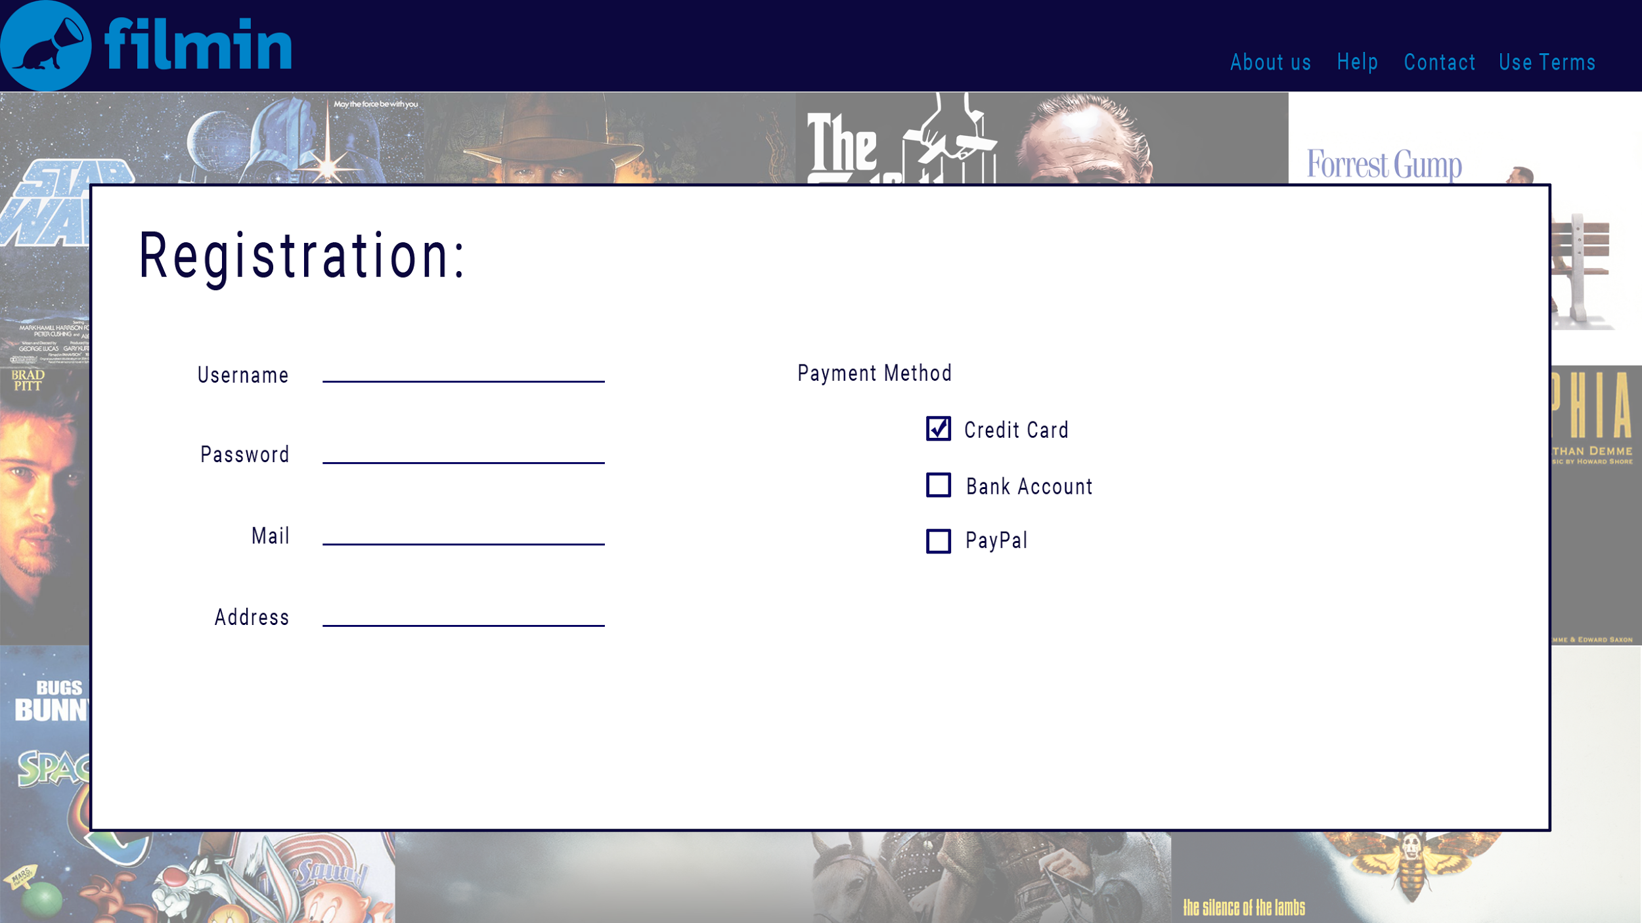

H3 - Guest Account:

It happens that many clients may refuse to use a site if they have to create or spend time creating an account. The option of using a website as a guest is recommended to avoid this problem. Filmin lets you to continue and enjoy part of its functionalities without registering or signing in.

H10 - Clear Forms:

Sometimes, when the user has to introduce data in a site, it could be frustrating, due to the format, the quantity of data required… Providing short and well-built formularies is a good idea to avoid it. Filmin requires few information and the registration process is fast and easy.

I2 - Above the fold:

Customers sometimes loss information if they have to scroll down to visualize it completely. It is ideal to show all the important information at the top of the page. Here, we show you the most popular content first, so you can directly charge it without scrolling.

J1 - Search Action Module:

Users usually want to swiftly jump from one point of the site to other. The searcher is in charge of this task. Here, the search module allows you to look for the film you have in mind in our catalogue.

K4 - Action Buttons:

It is a good idea for making a website intuitive to user buttons to represent actions. In Filmin, contrast of colors and icons are intended to express actions to make the user not to get loss thinking about what a button should do.

K11 - Familiar Language:

Unfamiliar terms may provoke navigating in a website becomes a difficult job. Using common language which most users understand may attract more visitors and make easier for them to empathize with the site. Here, we thought the page using a familiar language, knowing that many kinds of users can access to our service.

## Scenario of use:

Why does the user come to the site? Note what motivates the user to come to the site and their expectations upon arrival, if any.

What goals does he/she have? Through task analysis, you can better understand the what

the user wants on your site and therefore what the site must have for them to leave satisfied

How can the user achieve their goals on the site? Define how the user can achieve his/ her goal on the site, identifying the various possibilities and any potential barriers.

* Gabriel

Gabriel gets home from high school, he is tired and wants to rest and catch up on the new trends. He lays in bed and opens the site, he sees the login page and clicks the button to enter the site as his username and password are already stored in the cookies. As he uses his smartphone, he likes that the site is properly optimized for the use in smaller screens. When he enters, the home page is displayed, he takes a quick look at the content since he expects to find the main trendy videos of the day. He likes to be aware of new videos as it is the main topic of discussion among his friends and thanks to the home page he can be well informed about them. Once he has caught up with the videos he liked, Gabriel wants to disconnect from the world and he decides to watch a TV series as he has not enough time to watch movies, he has to study and then go practice football. Gabriel accesses the playlists section where he finds the list of TV series he is following at the moment. He selects the last in vogue TV series, everybody in his class talks about it so he decided to give it an opportunity. Before leaving to football practice he browses some popular playlists just in case he finds something interesting.

* Manuel

Manuel wakes up, he takes something to eat from the kitchen and eat it back in his bed. He has overslept. He should have gotten home earlier last night but his friends convinced him to stay. Provided that he is quite late to his macroeconomics class, Manuel decides to stay in bed and watch videos about last night’s basketball match and then an episode of a TV series he really enjoys in order to try to shut up the voice in his head telling him that he should be in class right now. He opens his favorite site, Filmin, and once he has logged in, he searches the best basketball playlist of the site, where he believes he will find the highlights of yesterday’s match. He watches a couple of videos of the playlist. Then, Manuel decides to make himself useful and attend the second lesson of the day, but not before watching an episode of his favorite TV show which he finds in his “Following” playlist. After using our site, Manuel feels prepared for the day.

* Apple

Apple has had a rough day at work, the main servers of the web in which she works as an administrator went down and the whole office was a mess. Once she is at home, she makes a sandwich and sits in front of her monitor setup. Apple enters the site and a in the home page a live broadcast of her favorite gaming YouTube. When she gets bored of the streaming, she switches to the categories part as this week she is the one choosing the movie that her boyfriend and she are watching tonight. She finds a Swedish movie which she finds interesting and adds it to the collaborative playlist that she shares with his boyfriend containing the movies they have watched at the moment.